Bluetooth Loudspeaker

Circuit description
The Bluetooth speaker is based on two off-the-shelf modules available online: an MH-M38 Bluetooth module, which includes a stereo amplifier, and a lithium battery charger module. The device is powered by a single 18650 Li-ion battery.
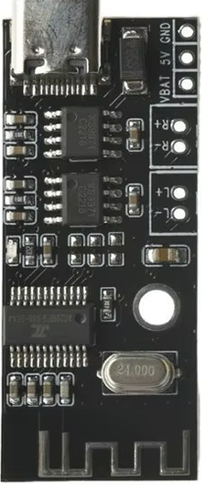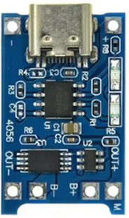

Assembly
We begin by installing the speaker connectors onto the Bluetooth module. Next, we mount both modules onto the circuit board using pin headers. We then install the power switch, along with the battery holder on the opposite side of the PCB. The pin headers on the charging module must be trimmed as short as possible on the side facing the battery holder.

Bringing to life
If you have worked carefully, the circuit should function on the first attempt. Before inserting the battery, it is advisable to check the quality of the soldering. Pay close attention to the battery polarity. Any error could destroy the electronics—lithium batteries are capable of delivering a high short-circuit current, which could lead to a fire.

Bill of materials
Annotation | Value / model | Qty
U1 | Bluetooth module MH-M38 | 1
U2 | Charging module | 1
SW1 | Turbo switch, 7x7mm | 1
BT1 | Accumulator holder 18650 | 1
 | Accumulator 18650 | 1
 | Loudspeaker 40mm | 2

Board assembly
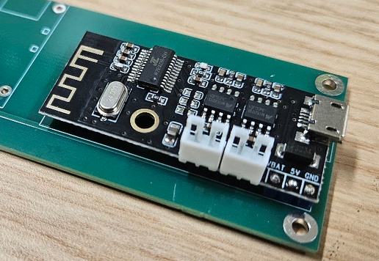
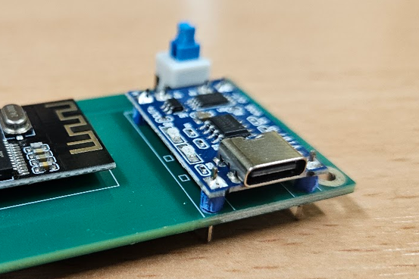
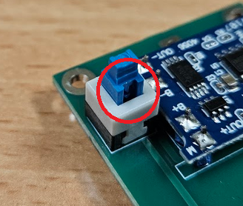

Mechanical assembly
The speakers are screwed into the mounts using three small screws, and wires (included with the Bluetooth module) are soldered to the speakers
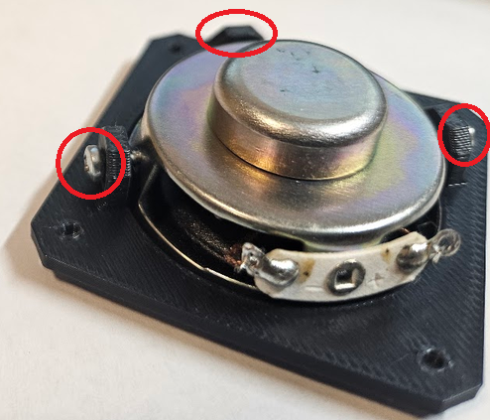
A tactile cap is attached to the switch using super glue.
Transparent light guides are glued into the holes intended for the LEDs. These conduct light from the modules to the front of the enclosure.
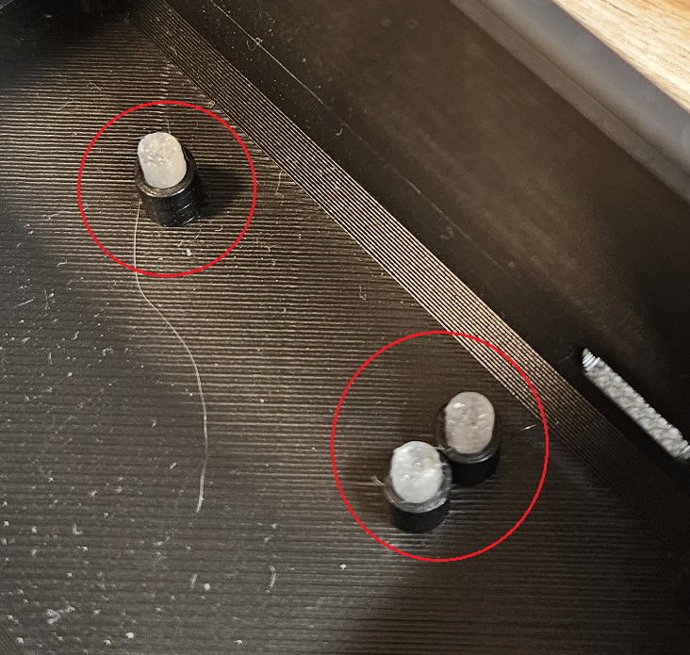
Finally, the speaker brackets are screwed onto the sides of the enclosure, the wires are connected to the Bluetooth module, and the entire printed circuit board is inserted into the enclosure and screwed in place.
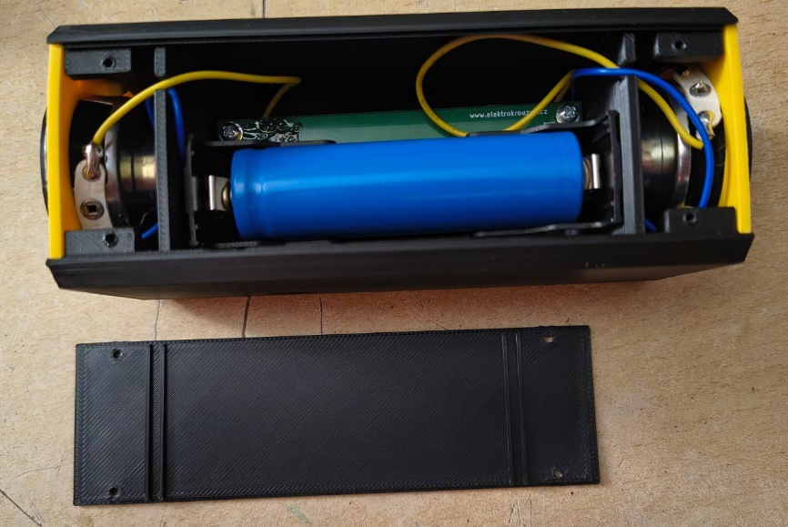

Assembly sheets

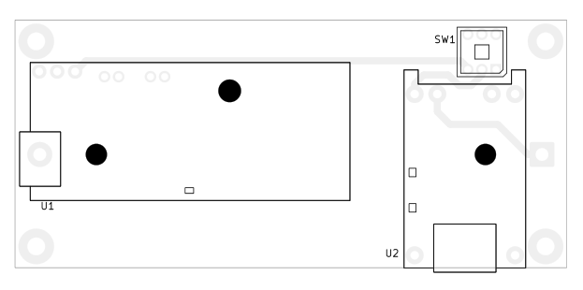
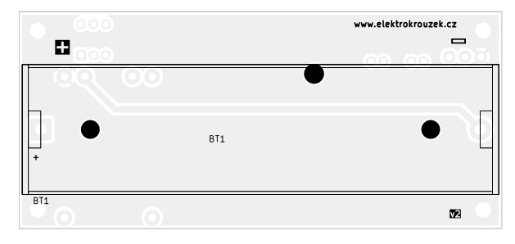

Schematic

